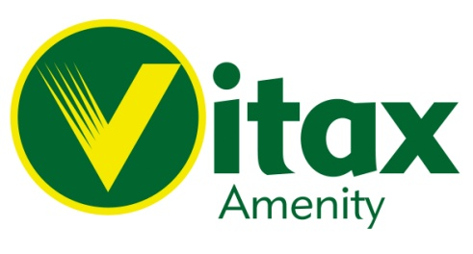
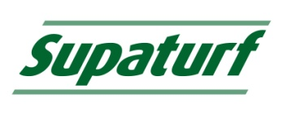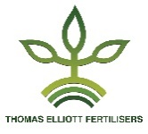
50/50 Iron©
50/50 Soluble & Liquid Iron

What
50/50 Soluble Iron’s are fast acting soluble products for the rapid greening and toughening of grass surfaces; ideal prior to major sporting events or where a high quality professional class appearance is essential.
- Available as an easily dissolved soluble powder or concentrated liquid formulation.
- Produces dark green turf.
- Toughens turf promoting disease resistance.
- Cost effective treatment for all types of sports turf surfaces.
- Stable improved formulation.
- Sulphur content provides rapid short-term pH reduction in the soil surface.
- Supplied in 10kg resealable tubs or 10 litre containers.
- Potash and Nitrogen free formulation, ideal for all year-round application.
- Iron (11) Sulphate Heptahydrate / Citric Acid formulation.

Why
Vitax Amenity 50/50 iron products offer the end user professional results at an affordable price. Available as either a soluble powder or concentrated liquid offers the user the choice of product to best suit their needs.
- Propagation of dark green healthy turf.
- Enhanced resistance to both wear and disease attack.
- Cost effective turf management.
- All year-round application for turf improvement.
- Applicable to all forms of sports turf.
- Only apply as necessary, avoid excessive application.
- Ideal for application with pedestrian controlled powered or mounted sprayers.

When
Ideal for all year-round application. For best results apply when to ground is moist (However, avoiding heavy rain).

Application
50/50 Soluble Iron.
Apply at 2.5kg in 90 litres of water per 1000 M² or 25kg in 900 Litres of water per hectare.

Application
50/50 liquid Iron.
Apply at 300ml in 6 to 10 litres of water per 1000 M² or 30 Litres in 600 to 1000 Litres of water per Hectare (10,000 M²).

Always follow the manufacturer’s instructions.
Clean equipment thoroughly after use, failure to do so will result in excessive corrosion to equipment.
Ideally clean tanks and spray lines with Vitax Amenity Spray Tank Cleaner.

Vitax Amenity
Owen Street
Coalville
Leicester
LE67 3DE
info@vitax.co.uk
01530 510060
Thomas Elliott
Selby Place
Stanley Industrial Estate
Skelmersdale
Lancashire
WN8 8EF
info@thomas-elliott.co.uk
01695 51863

